WALL STAND

LITHIUM BATTERY

SUE5K - 5.12KWH - 51.2V/100Ah

Main Features

 Class A cell, Strong and reliable quality.

 5000 cells cycle times, 5 years warranty, 10+ years

 life design. Power wall design, space saving design.

 High density, small size and weight.

 Big charge/discharge current up to 100A/200A, suitable for solar storage

 system. LCD display with communication port(CAN/RS485).

 All around protection.

 Optional smart BMS can communicate with Different Brand of Hybrid Solar Inverter.

Specification parameter

|  |  |
| --- | --- |
| MODEL | SUE5K |
| Battery Type | LiFePO4 |
| Normal Battery Model | 51.2V100AH |
| Normal capacity (25℃ 0.2C) (Ah) | 5.12KWh |
| voltage window (vdc) | 44.8 ~ 58.4V |
| Float charge voltage(vdc) | 55.2V |
| Max. continue discharge current(A) | 100A |
| Max. pulse discharge current(A) | 200A 1Sec |
| Max. continue charge current(A) | 100A |
| Terminal | M8 |
| Storage temperature | 0℃~ 30℃ |
| Storage duration | 6 months at 25℃ |
| Safety standard | UN38.3 , MSDS ,CE |
| IP degree | IP20 |
| Communication function | CAN/RS485: Intelligent BMS can communicate with multiple solar inverters ,  For example :Deye, Growatt, voltronic, GOODWE , SMA, SOFAR , etc. |
| PROTECTION | |
| Protection | Overcharge protection, over-discharge protection, over-current protection , short-circuit protection , over-temperature protection |
| AMBIENT | |
| Noise(dB) | < 40dB (1meter) |
| Working Temperature | - 10℃ ~ 50℃ |
| Humidity | 0 - 95% ( no condensation) |
| Sea level(m) | ≤ 1500 |
| DIMENSION | |
| LxWxH (products size) mm | 660*410*139mm |
| LxWxH (package size) mm | 740*490*219mm |
| Weight(NW Kg) | 44.2kg |
| Weight(GW Kg) | 46.9kg |

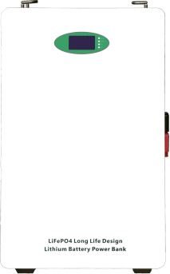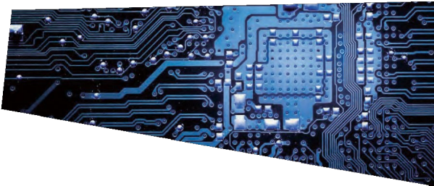CE UN383 MSDS IEC

WALL STAND

LITHIUM BATTERY

SUE10K - 10.24KWH - 51.2V/200Ah

Main Features

 Class A cell, Strong and reliable quality.

 5000 cells cycle times, 5 years warranty, 10+ years

 life design. Power wall design, space saving design.

 High density, small size and weight.

 Big charge/discharge current up to 100A/200A, suitable for solar storage

 system. LCD display with communication port(CAN/RS485).

 All around protection.

 Optional smart BMS can communicate with Different Brand of Hybrid Solar Inverter.

Specification parameter

|  |  |
| --- | --- |
| MODEL | SUE10K |
| Battery Type | LiFePO4 |
| Normal Battery Model | 51.2V200AH |
| Normal capacity (25℃ 0.2C) (Ah) | 10.24KWh |
| Voltage window (vdc) | 44.8 ~ 58.4V |
| Float charge voltage(vdc) | 55.2V |
| Max. continue discharge current(A) | 150A |
| Max. pulse discharge current(A) | 200A 1Sec |
| Max. continue charge current(A) | 100A |
| Terminal | M8 |
| Storage temperature | 0℃~ 30℃ |
| Storage duration | 6 months at 25℃ |
| Safety standard | UN38.3 , MSDS ,CE |
| IP degree | IP20 |
| Communication function | CAN/RS485: Intelligent BMS can communicate with multiple solar inverters ,  For example :Deye, Growatt, voltronic, GOODWE , SMA, SOFAR , etc. |
| PROTECTION | |
| protection | Overcharge protection, over-discharge protection, over-current protection , short-circuit protection , over-temperature protection |
| AMBIENT | |
| Noise(dB) | < 40dB (1meter) |
| working Temperature | - 10℃ ~ 50℃ |
| Humidity | 0 - 95% ( no condensation) |
| sea level(m) | ≤ 1500 |
| DIMENSION | |
| LxWxH (products size) mm | 880*660*160mm |
| LxWxH (package size) mm | 960*740*240mm |
| Weight(NW Kg) | 89kg |
| Weight(GW Kg) | 93kg |

CE UN383 MSDS IEC

WALL STAND

LITHIUM BATTERY PACK

SUE15K - 15.36KWH - 51.2V/300Ah

Main Features

Class A cell, Strong and reliable quality.

5000 cells cycle times, 5 years warranty, 10+ years life design. Stand by the wall design, space saving design.

Strong and durable, reliable quality.

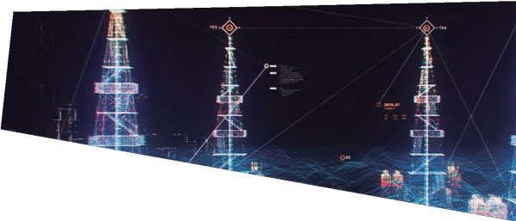Big charge/discharge current up to 100A/200A, suitable

for solar storage

system. LCD display with communication port(CAN/RS485).

Optional 51.2V smart BMS can communicate with Different Brand of Hybrid Solar

Inverter.

Specification parameter

|  |  |
| --- | --- |
| MODEL | SUE15K |
| Case design | Wall stand |
| Battery Type | LiFePO4 |
| Normal Battery Model | 51.2V300AH |
| Normal capacity(25℃ 0.2C) | 15.36KWh |
| Voltage window (vdc) | 44.8 ~ 58.4V |
| Float charge voltage(vdc) | 56.0v |
| Max. continue discharge  current(A) | 150A |
| Max. pulse discharge current(A) | 200A 30sec |
| Max. continue charge current  (A) | 100A |
| Terminal | M8 |
| Storage temperature | 0℃~ 30℃ |
| Storage duration | 6 months at 25℃ |
| Safety standard | UN38.3 , MSDS |
| IP degree | IP20 |
| communication function | CAN/RS485 : Intelligent BMS can communicate with multiple solar inverters ,  For example :Deye, Growatt, voltronic, GOODWE , SMA, SOFAR , etc. |
| PROTECTION | |
| protection | Overcharge protection, over-discharge protection, over-current protection , short-circuit protection , over-temperature protection |
| AMBIENT | |
| Noise(dB) | < 40dB (1 meter) |
| Working Temperature | -l0℃~+50℃ |
| Humidity | 0 - 95% ( no condensation) |
| Sea level(m) | ≤ 1500 |
| DIMENSION | |
| LxWxH (products size) mm | 453*406*746mm |
| LXWxH (package size) mm | 826*511*225mm |
| Weight (NW Kg) | 145.0kg |
| Weight (GW Kg) | 158.0kg |

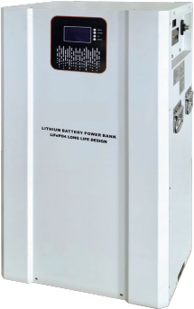

CE UN383 MSDS IEC